**Splunk Lab P2**

Matthew Dias

* Intro to Knowledge Objects

* Creating Knowledge Objects

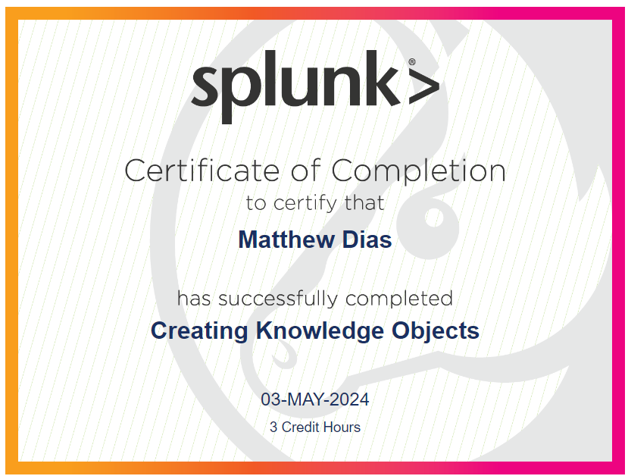

* Creating Field Extractions

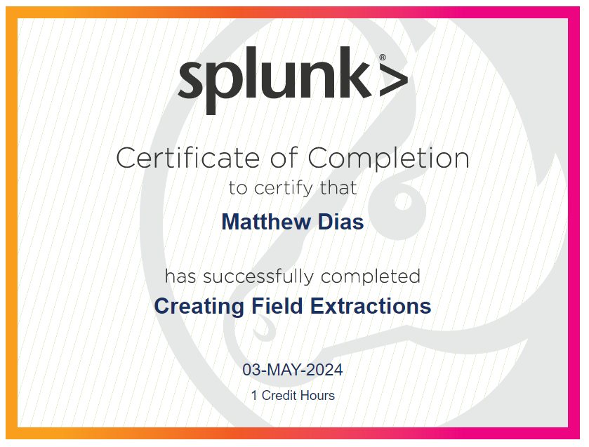

* Enriching Data with Lookups

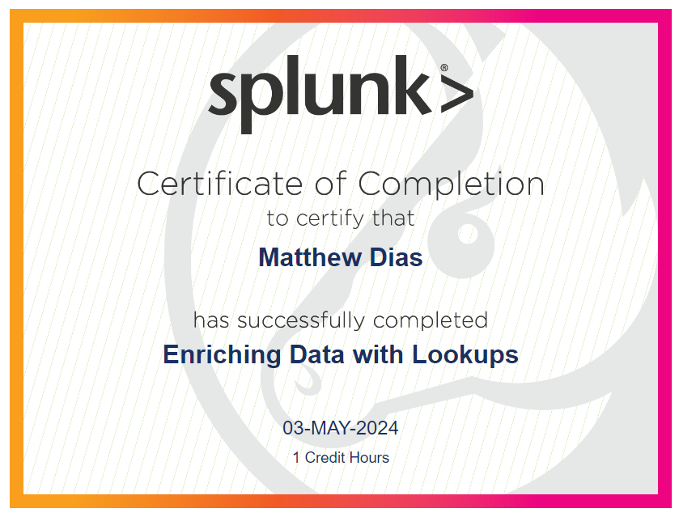

* Data Models

